**HOME**

**User Interface Description**

Version 0.1

Developed by Dao Quoc Trung

**Revision History**

|  |  |  |  |
| --- | --- | --- | --- |
| Name | Date | Reason to change | Version |
| Trung | 03/06/2021 | Initialize document | 1.0 |
|  |  |  |  |

**Table of Contents**

**Revision History**

1. **COMMON 4**
   1. Font 4
   2. Layout 4
   3. Button Image 5
2. **Status Bar 5**
3. **Widget 6**
   1. Map 6
   2. Climate 7
   3. Music 11
4. **Application Menu 14**
5. **Application 16**
6. **COMMON**
7. Font

* Using Arial
* Font size unit: pixel

1. Layout

|  |  |
| --- | --- |
| Figure 1 Width and Height | Status Bar Area  Widget Area    Application Menu Area |

1. Button Image

|  |  |  |
| --- | --- | --- |
|  |  |  |
| Normal | Pressed | Focus |

|  |  |  |
| --- | --- | --- |
| State | Description | Image Source |
| Normal | When item not selected on pressed by mouse/touch | xxx_n.png |
| Pressed | When item press by mouse/touch | xxx_p.png |
| Focus | When user using keyboard to selected item | xxx_f.png |

1. **Status bar**

Layout



Figure 2 Width and Height

|  |  |  |  |
| --- | --- | --- | --- |
|  | Default font 36px  Center Align  Normal: #FFFFFF |  | Default font 36px  Center Align  Normal: #FFFFFF |

|  |  |  |  |
| --- | --- | --- | --- |
| No. | File Name | Size(Pixel) | Folder |
| A | Icon_phone_signal_n.png | 30x30 | Status Bar |
| B | Icon_wifi_network_n.png | 30x30 | Status Bar |
| C | Icon_battery_n.png | 30x30 | Status Bar |

1. **Widget**

Layout

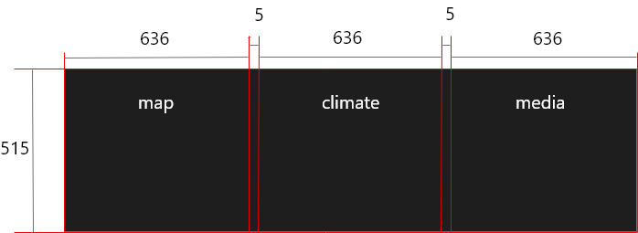

Figure 3.1 Layout

* 1. Map

|  |  |
| --- | --- |
| Layout |  |

Figure 3.2 length and width of widget

|  |  |  |  |
| --- | --- | --- | --- |
| Status |  |  |  |
| Normal | Pressed | Focus |
| Figure 3.2 | Figure 3.3 | Figure 3.4 |
|  |  |  |  |

* 1. Climate

Layout

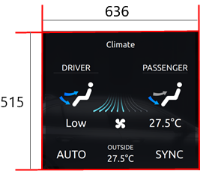

Figure 3.5 Width and length

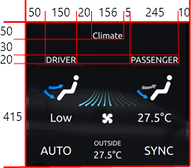

Figure 3.6 x and y position of climate, driver and passenger

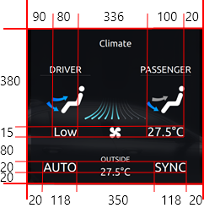

Figure 3.7 x and y position of Low, 27.5 and auto, sync

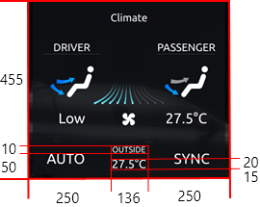

Figure 3.8 x and y position of outside and 27.5

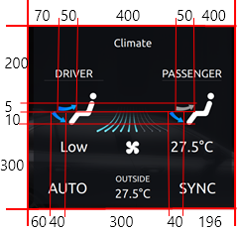

Figure 3.9 x and y position of icon wind direction

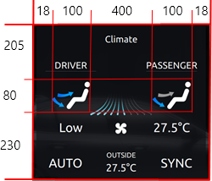

Figure 3.10 x and y position icon human

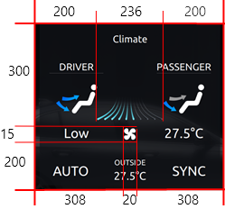

Figure 3.11 x and y position of icon Pan and Fan Strength

|  |  |  |  |  |  |  |  |  |  |
| --- | --- | --- | --- | --- | --- | --- | --- | --- | --- |
| Figure 3.12 Text | |  |  | | --- | --- | |  | Default font 20px  Center Align  Normal: #FFFFFF | |  | Default font 22px  Center Align  Normal: #FFFFFF | |  | Default font 23px  Center Align  Normal: #FFFFFF | |  | Default font 24px  Center Align  Normal: #FFFFFF | |

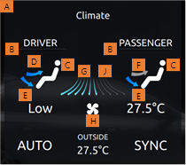

Figure 3.12 Icon

|  |  |  |  |
| --- | --- | --- | --- |
| No. | File Name | Size(Pixel) | Folder |
| A | Img_background_climate_n.png | 636x515 | Back Ground |
| B | Img_title_bar_n.png | 120x10 | Status Bar |
| C | Icon_human_n.png | 30x60 | Icon |
| D | Icon_wind_above_on_n.png | 30x20 | Icon |
| E | Icon_wind_below_on_n.png | 30x20 | Icon |
| F | Icon_wind_above_off_n.png | 30x20 | Icon |
| G | Icon_Strength_fan_bar_on_n.png | 240x50 | 240x50 |
| H | Icon_fan_on_n.png | 30x30 | Icon |
| J | Icon_Strength_fan_bar_off_n.png | 240x50 | 240x50 |

|  |  |  |  |
| --- | --- | --- | --- |
| Status |  |  |  |
| Normal | Pressed | Focus |
| Figure 3.13 | Figure 3.14 | Figure 3.15 |

* 1. Music

Layout

|  |  |
| --- | --- |
|  | Figure 3.14 With and Height |
|  | Figure 3.15 x and y position of text |
|  | Figure 3.16 x and y position of Icon |

|  |  |  |  |  |  |  |  |
| --- | --- | --- | --- | --- | --- | --- | --- |
| Figure 3.17 Text | |  |  | | --- | --- | | C:\Users\Trung\AppData\Local\Microsoft\Windows\INetCache\Content.Word\Component 13 – 1.png | Default font 20px  Center Align  Normal: #FFFFFF | |  | Default font 19px  Center Align  Normal: #FFFFFF | |  | Default font 22px  Center Align  Normal: #FFFFFF | |

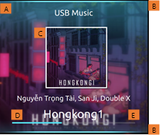

Figure 3.18 Icon

|  |  |  |  |
| --- | --- | --- | --- |
| No. | File Name | Size(Pixel) | Folder |
| A | Img_background_song_n.png | 636x515 | Song |
| B | Icon_blue _bar_n.png | 636x10 | Icon |
| C | Icon_Song_Art_n.png | 120x180 | Song |
| D | Icon_running_bar_n.png | 620X10 | Status Bar |
| E | Icon_process_bar_n.png | 620x10 | Status Bar |

|  |  |  |  |
| --- | --- | --- | --- |
| Status |  |  |  |
| Normal  Figure 3.19 | Pressed  Figure 3.20 | Focus  Figure 3.21 |

1. **Application Menu**

Layout

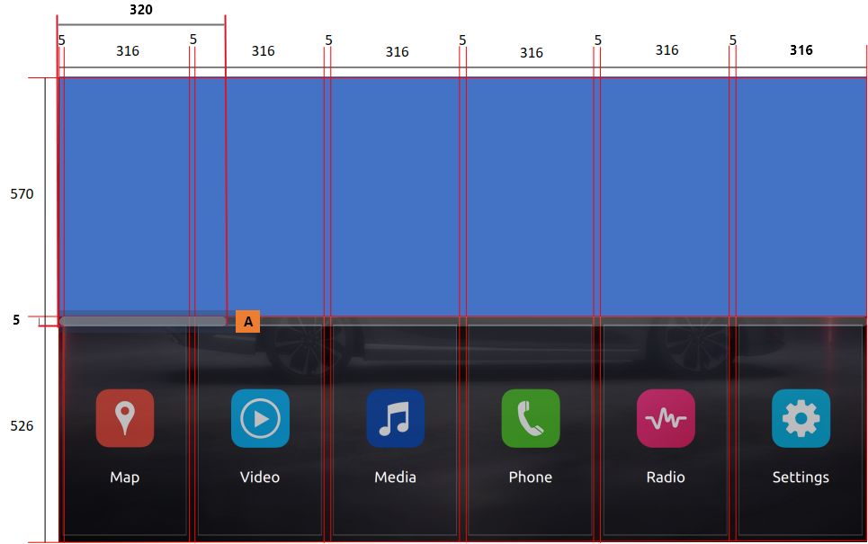

Figure 4.1 width and height of layout and Icon

|  |  |  |  |
| --- | --- | --- | --- |
| No. | File Name | Size(Pixel) | Folder |
| A | Icon_scroll_bar_n.png | 320z5 | Menu |

Status

|  |  |
| --- | --- |
|  | Normal  Figure 4.2 |

|  |  |
| --- | --- |
|  | Pressed  Figure 4.3 |

|  |  |
| --- | --- |
|  | Focus  Figure 4.4 |

Application Button

|  |  |  |  |
| --- | --- | --- | --- |
| Figure 4.5 Widget, Height, Icon and Text | |  |  | | --- | --- | |  | Default font 36px  Center align  Normal:#FFFFFF | |

|  |  |  |  |
| --- | --- | --- | --- |
| No. | File Name | Size(Pixel) | Folder |
| A | btn_app_layout_n.png | 316x350 | Home Screen |

1. **Application**

Layout

|  |  |  |  |
| --- | --- | --- | --- |
| Figure 5.1 Widget, Height, Icon and Text | |  |  | | --- | --- | |  | Default font 36px  Center align  Normal:#FFFFFF | |

|  |  |  |  |
| --- | --- | --- | --- |
| No. | File Name | Size(Pixel) | Folder |
| A | Icon_return_n.png | 60x30 | Icon |
| B | img_background_home_app_n.png | 1920x1080 | Back Ground |